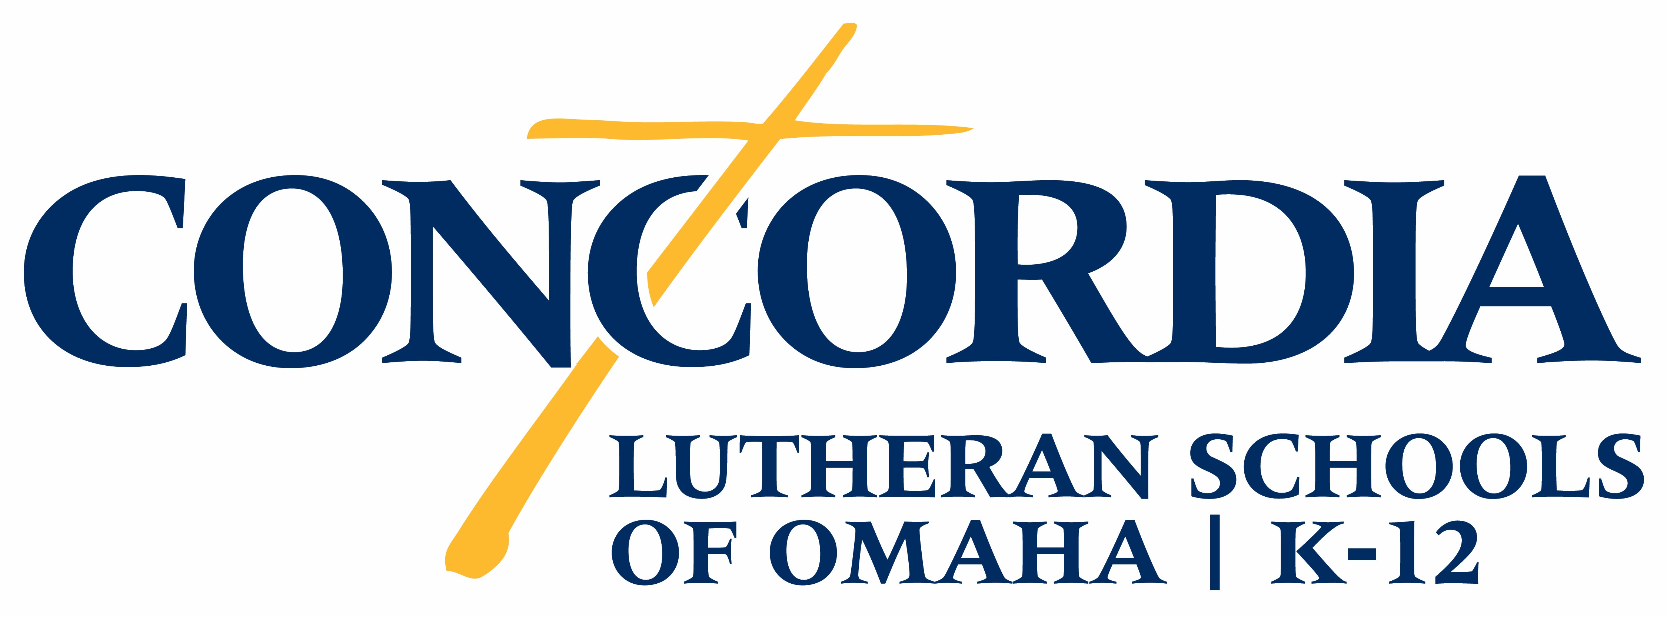

CONCORDIA LUTHERAN SCHOOLS OF OMAHA INTERNATIONAL STUDENT APPLICATION

Please complete your application and submit it to international@concordiaomaha.org. At the same time you must submit your application fee of $100, a copy of your passport picture page and your most recent transcripts/grades. The application fee can be sent by wiring funds to Concordia or by mailing a check to:

Concordia Omaha
15656 Fort St.
Omaha, Nebraska 68116

For questions, please contact the International Studies Director,
at international@concordiaomaha.org by calling 402-445-4000.

Student’s First Name__________________ Middle Name____________ Last Name ____________________

Male Female Birthdate (Month/Date/Year) / /

City, State and Country of birth: ______________________________________________________________

Student's Email Address: ___________________________________________________________________

Student's current grade _____________ The grade student wishes to enter at Concordia _________________

Previous School Name & Country Location? _____________________________________________________
_____________________________ Has the student studied in the US before? _________________________
If so, where? _____________________When do you wish to begin classes at Concordia? _________________

Do you intend to attend Concordia through to graduation (12 grade)? __________________________________

Student Height (in inches) __________Student Weight (in pounds) _________________(For uniform purposes)
Do you have an American name you will use at Concordia? (If so please list)
Do you currently attend church with your family? _________This is NOT required but helps with class planning.
Current Address
City _______________________________ State/Province
Country Zip Code
Father’s First Name Middle Name Last Name

Mother’s First Name Middle Name Last Name

Parent’s Address if different from above

City

State/Province Country Zip Code

Home Telephone # Father's Cell # Mother's Cell #

Father's Email Address:

Mother's Email Address:

What is the best way to do an online interview with the student? (Zoom, WeChat, Viber, Kakao)
__________________________________________________________________________________________

What is your user id for the above social app?? ____________________________________________________

Will you live with family in Omaha or do you need a Host Family?______________________________________

Why does the student wish to attend Concordia?

At this time, what are the student’s plans for their future career? (Medicine, Business, Art) __________________
__________________________________________________________________________________________

Does the student take any medication on a regular basis that has been prescribed by a doctor?
__________________________________________________________________________________________

Does the student have any diagnosed learning disabilities (ADHD, Autism, Dyslexia)?_
__________________________________________________________________________________________

Does the student have any allergies (pets, foods or medicines)? If so, please list below.
__________________________________________________________________________________________

What is the student’s favorite subject in school and why?

What is the student’s least favorite subject in school and why?

Is the student currently under the care of a doctor for counseling or any health issues?

Does the student take part in extracurricular activities? (Music, Art, Dance or Academic clubs)

Does the student play a musical instrument (drums, flute, guitar, piano, trumpet, saxophone, clarinet)?
__________________________________________________________________________________________

Does the student currently play sports and would they like to play sports at Concordia (basketball, soccer, etc)?

How did you learn about Concordia Omaha?

Are the parents able to completely financially support the student?

*We suggest students have $200 for personal expenses for each of the 10 months of the school year.
*****Please include 5 pictures of the student. This is helpful when matching with a host family.

A $2,000 deposit must be made by June 1st with the remaining tuition funds due to Concordia Omaha no later than August 1st.

Father’s Signature Mother’s Signature

Student Signature Date
****Please do not forget to submit your most recent school transcripts, immunizations and passport picture page with your application. Also, the $100 application fee is due when you submit your application.

